**RAW.REAL.RIPPED.ROCKING Honda unveils the CB Hornet 160R in Bangladesh**

**Dhaka- February 16, 2018:** Bangladesh Honda Private Limited (BHL), unveiled the Street Naked Sports Bike- CB Hornet 160R on **16th February** 2018 at International Convention City Bashundraha (ICCB). Raw, Real, Ripped and Rocking, the all new CB Hornet 160R stands out in its category with its aggressive styling and cutting edge performance.

**Aggressive Style & Design**

The CB Hornet 160R is designed to set the pulse racing with its looks. The sharp and edgy headlight with two position lamps and upward facing side indicators create the bold first impression and improved functionally. The new generation X-Shaped LED tail light enhances the rear look of the bikes. Aerodynamically forward leaning dynamic tanks shrouds add muscle to the bike.

The character of CB Hornet 160R is amplified by the sporty short muffler. True naked street sports bike experience is enhanced further by 140mm wide rear tyre which increase the stability while the uniquely crafted 5 spoke split alloy wheels further add to its looks.

**New air-cooled 163cc 4 stroke engine**

Powered by a **163cc** engine, the CB Hornet 160R boasts **15.3 ps** net power and **14.76 nm** torque, as max. powerful in this segment. Specially designed to deliver good low end torque, the advanced engine also achieves a compression ratio of **10:1**, delivering the right punch of power. Further, its engine is equipped with a counter balancer to reduce the vibrations produced in engine.

Honda CB Hornet 160R is top end the Street Naked Sports motorcycle in Bangladesh with outstanding **fuel efficiency**, **mono-suspension** and Automatic Headlight on (**AHO)** for safety in roads using the latest technologies by Honda.

The CB Hornet 160R comes in 3 new electrifying accents colors- **Striking Green, Sports Red & Athletic Blue Metallic**.

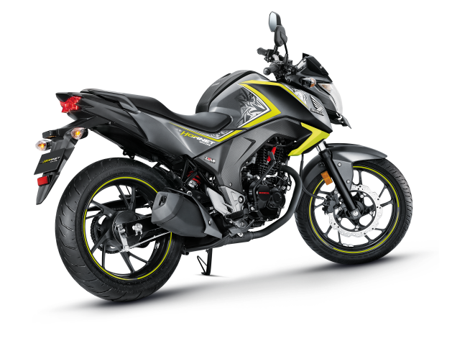

BHL offer CB Hornet 160R with attractive warranty policy of “**2 years or 20,000 km**” whichever comes earlier, with **four** free Services.

CB Hornet 160R will be available in every Honda dealer showroom from 17th February 2018 with an attractive retail price.

**Company Information:**

Bangladesh Honda Private Limited (BHL) operates in a single industry segment in Bangladesh under a joint venture between Honda Motor Company Limited, Japan and Bangladesh Steel and Engineering Corporation (State Own Corporation) under The Ministry of Industry, The Peoples Republic of Bangladesh. Bangladesh Honda Private Limited is always committed for **Change The Life** with affordable mobility.

**About Bangladesh Honda Private Limited (BHL) :**

Established : December 2012

Representative : Yuichiro Ishii, Managing Director and CEO

Location : Gazipur, Bangladesh

Capital investment : 610 million Bangladeshi Taka

Capitalization ratio : 70% Honda Motor Co., Ltd.

30% Bangladesh Steel and Engineering Corporation

Business : Import, production and sales of motorcycles and motorcycle parts

**The Office of Bangladesh Honda Private Limited:**

Corporate Office : Saimon Centre, House # 4/A, Road # 22,

Gulshan-1, Dhaka -1212, Bangladesh

Phone : +88 02 985 8361

Email : info@bdhonda.com

Existing BHL plant : Gazipur, Bangladesh

New BHL plant : Abdul Monem Economic Zone, Char Baushia, Gajaria,

Munsiganj, Bangladesh

**Attachment: CB hornet 160R specification**

|  |  |
| --- | --- |
| **BODY DIMENSIONS:** | |
| Length | 2041 mm |
| Width | 783 mm |
| Height | 1067 mm |
| Wheel Base | 1346 mm |
| Ground Clearance | 164 mm |
| Kerb Weight | 138 kg |
| Fuel Tank Capacity | 12.0 L |
| **ENGINE:** | |
| Type | Air Cooled, 4 Stroke, Sl Engine |
| Cylinder Capacity | 163 cc |
| Bore | 57.30 mm |
| Stroke | 63.09 mm |
| Compression Ration | 10:01 |
| Air Filter Type | Viscous Paper Air Filter^ |
| Starting Method | Self/Kick |
| **Performance:** | |
| Max Net Power | 15.3 ps |
| Max Net Torque | 14.76 Nm @ 6500 rpm |
| Max Speed (recommended) | 110 kmph |
| Mileage | 64 km |
| **TRANSMISSION:** | |
| No. of Gears | 5 |
| Gear Pattern | 1-N-2-3-4-5 |
| **BRAKES:** | |
| Brake Type & Size (Front) | Petal Disc 276 mm |
| Brake Type & Size (Rear) | Drum 130 mm |
| **WHEEL & TYRES:** | |
| Wheel Type | Alloy Wheel- 5 Split Spokes |
| Front Tyre (Size & Type) | 100/80-17 Tubeless |
| Rear Tyre (Size & Type) | 140/70-17 Tubeless |
| Tyre Type (Front) | Tubeless |
| Tyre Type (Rear) | Tubeless |
| **FRAME & SUSPENSION:** | |
| Frame Type | Diamond |
| Front Suspension | Telescopic |
| Rear Suspension | Monoshock |
| **ELECTRICALS:** | |
| Battery | 12V 4Ah (MF) |
| Head Lamp | 12V 35/35W |